**PO BOX – Pulse Oximeter**

**ABSTRACT**

**By: Dariosh Abdollahi**

MOTIVATION:

The purpose of this paper is twofold; to demonstrate the concept of Pulse Oximetry using a Microchip dsPIC30F Digital Signal Processor and as an entrant into the 2007 Microchip 16-Bit Embedded Control Design Contest sponsored by Microchip and Circuit Cellar.

Over the past number of years I have had experience with the nursing home setting since my uncle had spent two years there. It is very common for bed-ridden patients to contract pneumonia during the flu season. A pulse oximeter is normally used to determine if the patient is having difficult time breathing. A particular nursing home my uncle was in had one such instrument. During the winter, he had contracted pneumonia; I asked the nurse if he could be examined. They had to wait for the oximeter because it was being used in another part of the building. Because of the instruments high cost, the nursing home couldn’t afford a second or perhaps a third.

Some time earlier, when my mother was hospitalized with what the doctors though was pulmonary fibrosis, my wife and I looked for a pulse oximeter that we could purchase that she could use when she came home from the hospital. They were all very expensive. During our search, we read an interesting article of an individual who was on the same quest. With his level of the fibrosis disease, he was able to exercise. He wanted to monitor his oxygen level during his workout. He couldn’t find a unit that he could afford. His question was - does anybody make one? With the low cost and availability of microchips, I can’t understand why these instruments are so expensive and why they are not available at your local drugstores like glucose meters.

**THEORY**

The fundamental basis for Oximetry is that blood has different optical properties at different levels of oxygen saturation. This means that if multiple sources of light at different wavelengths are used to examine the blood, they can be compared algorithmically by a computer to determine the level of oxygen saturation in the blood. The beauty of the concept is that the examination can be made invasively by passing light through an extremity such as a finger, ear lobe, etc. The light is collected by a light sensitive solid-state device such as a photo-detector, phototransistor or more recently a LTF (Light to Frequency) converter. Oximeter probes are designed to have multiple light sources (LEDs) that are switched on/off during the measurement phase of the instrument.

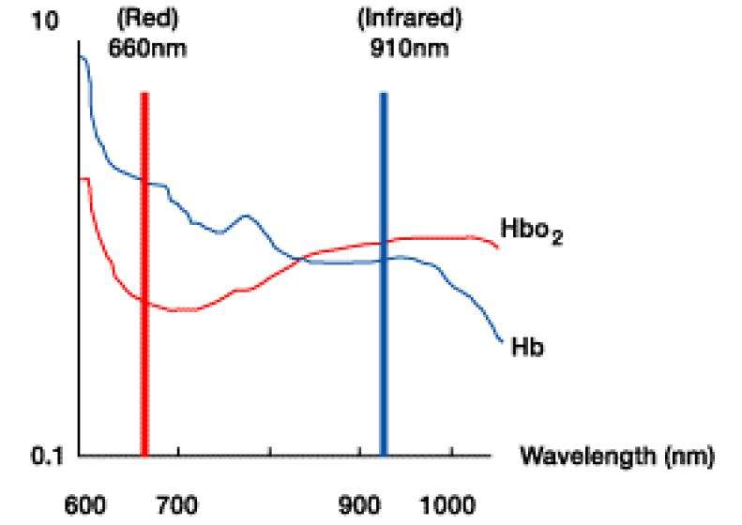The oxygen carrying component of blood is called Hemoglobin. It is also the colored substance in your blood. The amount of absorption of visible light changes with the level of oxygenation. On a molecular scale, there are two forms of the hemoglobin molecule. One is called oxidized hemoglobin (HbO2) and the other is called reduced hemoglobin (Hb). Both of these molecular forms have different optical characteristics. The absorption of both forms of hemoglobin can be seen below.

FIGURE 1:

The graph shows the absorption spectra of both HbO2 and Hb. Hb has a higher absorption than HbO2 at 660nm (Red light). In the infrared region, HbO2 has a higher absorption. The point were the absorption of the HbO2 and the Hb are equal is called the isobestic point.

R IR

` FIGURE 2: Basic Oximeter Sensor Components LTF

Above, illustrates two LED sources (RED and INFRARED) that transmit light through a finger. The light is received by the LTF (Light to Frequency sensor). The output of this sensor has a frequency that is proportional to the intensity of the light for each source. The sources are time multiplexed. Each source is switched on for a brief instant and the frequency is measured. Light is absorbed from each source by the tissue as well as the blood. The absorption is different in the tissue for each source. As blood flows through the finger a pulsitile component is present. The pulsatile component represents the arterial flow of the blood which contains 97% of the oxygen in the body. The constant or DC component that is picked up by the LTF represents the tissue, venous and capillary absorption. Below shows the pulsitile and DC components for each of the signals. The RED trace represents the RED source and the BLUE trace represents the IR trace. The Black line represents the DC value for each of the sources.

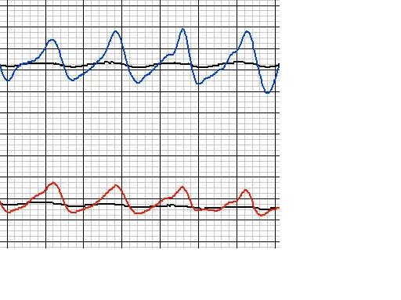

FIGURE 3: Blue Trace– IR Light / Red Trace – RED Light

The appendix of this paper goes into more detail on the theory behind the equations that govern how with a few simple measurements the blood oxygen saturation can be obtained from the signals above. The system measures both the AC and DC levels obtained from both sources and computes the SPO2 based on the following equation:





The above equation is a 3rd order polynomial fit to the SpO2 graph given in reference [4]. The graph is shown below and also in appendix 3.

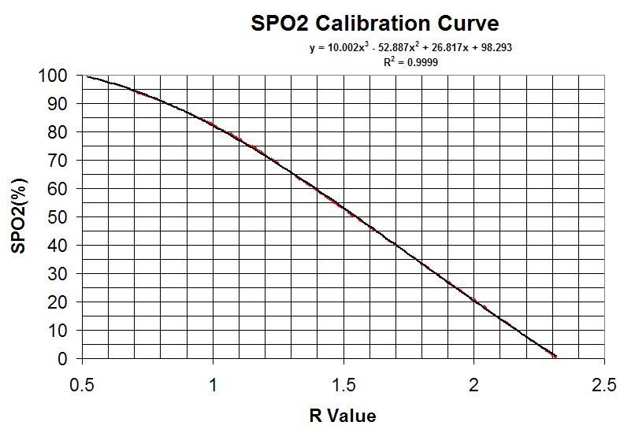

FIGURE 4: Calibration curve for oximeter

The Heart Rate is determined by measuring the elapsed time between peaks of the IR signal. The heart rate is then calculated using the equation:



BEER-LAMBERT LAW:

σ

Iz Iz-dI

A

Io IiIiz Iz I I I

Z dZ, dI

B

The Beer-Lambert model can be derived for a material of absorbing species. First

## consider the absorption dI, of an infinitesimal cross-sectional slab of material of thickness dZ. The total length of the path of the material is B with a total cross-section of A. The intensity is Io at Z=0 and I at the full length of the material. The intensity at Z is Iz. The intensity after the absorption dI is (Iz – dI). Consider a molecular cross section of σ (cm2). If there is a concentration of N (mol/cm2) absorbers in this molecular cross section. Then the total absorbed light on this infinite cross-sectional slab would be:

σ * N * A * dZ (cm2) * (# mol/cm3) * (cm2) * (cm) = #mol*cm2

The fraction of photons absorbed across this surface area A is:

σ * N * A * dZ / A = σ * N * dZ (#mol)

The fraction of the photons absorbed across dz becomes,

-σ * N * dZ = dI/Iz

Integrating both sides,



 

Remember that absorbance is equal to the left side of the equation, and then the equation becomes:

### A = σNB

Since N (molecules/cm3) *(1 mol/6.023x1023 molecules) * 1000 cm3/liter = c (mol/liter)

and 2.303 * log(x) = ln(x)

then, 



or,

where, ε = σ * (6.023 x 1020/2.303) = σ * (2.61 * 1020)

So,



### Beer-Lambert Law

##### OXYGEN SATURATION

Hemoglobin is the primary component that carries oxygen from the lungs to the rest of the body via passages called arteries, veins and capillaries. It is a protein that is bound to the red blood cells. Oxygen is chemically combined with the hemoglobin inside of the red blood cells and makes up nearly all the oxygen present in the blood.

The absorption of visible light at different frequencies by hemoglobin varies with oxygenation as can be seen in Figure 1 (THEORY section). Two forms of the hemoglobin molecule are oxidized (HbO2) and reduced hemoglobin (Hb).

The oxygen saturation is defined, as SaO2 (SPO2) and s a function of the concentration of the two forms of hemoglobin in the blood:



Where,

Ko = Concentration of HbO2

Kr = Concentration of Hb

Arterial SpO2 is a parameter measured with Oximetry and is normally expressed as a percentage. Under normal conditions, arterial blood is 97% saturated while venous blood is 75% saturated.

The wavelength range 600nm – 1000nm is the range for which there occurs the least amount of attenuation of light by body tissue because tissue and pigmentation absorb blue, green and yellow light and water absorbs the longer infrared wavelength.

The Oxygen Saturation (SPO2) of the arterial blood may be determined by measuring the transmitted light through the fingertip or earlobe at two different wavelengths and then compared ratiometrically. The two wavelengths that best suit this type of measurement are RED (660nm) and INFRARED (940nm).

According to the Beer-Lambert law there is a linear relationship between the absorbance and concentration of each component of the blood at that particular frequency of light. Also, the intensity of the light will decrease logarithmically with the path length.

Io I

Z

Suppose we had a source of length Z with incident light intensity Io and transmitted intensity of I. If there were two species of absorbers called HbO2

(RED) and Hb (Blue) with the concentrations Ko and Kr respectively. These are analogous to oxygenated hemoglobin and reduced hemoglobin. Now supposed we examine the specimen using two light sources 1 and 2.

Using Beer-Lambert law, at each wavelength, we get:



At (λ1) 



At (λ2 )

Where:

K0  = concentration of hemoglobin

K1 = concentration of reduced hemoglobin

αo1 = absorption coefficient of HbO2 at λ1

αr1 = absorption coefficient of Hb at λ1

αo2 = absorption coefficient of HbO2 at λ2

αr2 = absorption coefficient of Hb at λ2

Writing both equations in log form:





We can express both functions as the ratio (R).





Then solving for Kr,



Substituting this into the equation for SaO2 yields:





Where:

Below is a graph of the above equation showing the theoretical values. The second trace shows an actual calibration using arterial blood samples. This is the curve for the HP M1190A probe. The difference has been found to be caused mainly by scattering effects and non-ideal light sources.



Using Matlab, analyzing the graphical data above, data from the real calibration curve shown above was extracted into vector form. The data was input into Microsoft excel and fit to a 3rd order equation. It is this equation which expresses SpO2 = f (R) that was used in this project. The graph of this data and the fit equation are shown below.



AFFORDABLE MODEL:

After multiple attempts in trying to work out a usable model for a pulse oximeter, I was very excited when this opportunity to work with the Microchip product came forth. Not only does Microchip have great processors at affordable prices, but they have other devices to support the design. Having worked with Microchip products in the past, I know they have a great support team in place when assistance is required. The goal to complete this project as a contestant in the Microchip/Circuit Cellar contest is only a step in getting the PO Box to market as a product.

PBLOCKX

APPROACH:

The block diagram on the previous page shows the basic architecture of the Microchip concept. **PO Box** was designed around the 16-bit 28-Pin Development tool that Microchip markets. This board was used in conjunction with Microchips ICD-2 tool and the C30 compiler in the MPLAB environment. A small interface proto-board was built that connects to the 28-Pin development board through a header. I called this the mezzanine board since it sits atop the Microchip board. The mezzanine board holds a display and all the necessary circuitry to interface to the sensor and a host computer. The UART on the microchip was used during the development of this project to display real-time data. Since the data out of the UART was ASCII, I wrote a small LabVIEW (scope) program to convert and display this data. The idea was to develop a concept, come up with a working model (goal for this contest), then layout a board that contains all the circuitry while keeping the cost down (the normal engineering feat). The Microchip 28-pin board was a good choice for doing the development work since it allowed access to all the hardware inside the chip providing freedom me to make choices on which hardware to use.

After reading an interesting article in Circuit Cellar a number of years ago (Dec 2004/Jan 2005) about using a Light to Frequency converter chip built by Taos Inc. (Texas Advanced Optoelectronic Solutions), I was motivated to develop an inexpensive sensor using the LTF technology. The sensor that I developed was made from a commercially available 1" Velcro strap cut to about 4-6" length. Two holes are punched into the strap at a distance equal to 1/2 the girth of the index finger. The LTF sensor and LED emitter package peeks through these holes. An old abandoned serial mouse cable was used to connect the sensor to the instrument.

The beauty of the sensor is that is very affordable and reusable.

The final design will consist of a small enclosure housing a single circuit board and display. Using surface mounted devices, it will be of small physical size and lightweight. This gives the user the option to mount it on the forearm (Velcro strap) or on the belt (clip) for the person interested in monitoring their vitals while exercising, or it may simply be hand-held.

RESULTS:

I had very good results with the prototype, but there is a lot of room for improvement. The digital filters used were developed by emulating analog filters. I developed all the filters by converting an analog specification into an equivalent IIR filter. Since the processor had plenty of speed, floating-point operations were used instead of fixed integer. All-in-all, the filters worked out very well. The software uses a 4th order LP filter on both the IR and RED signals (cleans them up very nicely). On the next page is an output which shows the results.

A differentiator and peak follower are used to look for sharp transitions in the filtered signal for framing and synchronizing to the heart-wave. This is required to take timing measurements to calculate the heart rate and measure the SPO2 level.

A DC tracking filter is also part of the software. The result of the filtered signal and the DC are used to calculate the AC portion of the signal which contains the arterial component which has 97% of the oxygen. Finally the heart rate and SPO2 are averaged using a Simple Moving Average filter. The results provide a relatively stable reading.



FIGURE 1: Response from Sensor (RED – Red light)/ BLUE – IR light

CONCLUSIONS:

I am very happy with the results of this project. The only regret is that I should have spent more time and did a circuit board layout from the get-go. The mezzanine board was built using point-to-point wiring which didn’t turn out too bad. A circuit board would have produced a much cleaner prototype. The next steps beyond this project are to do a board design and refine the software. Hopefully a fine product can come out of this work.

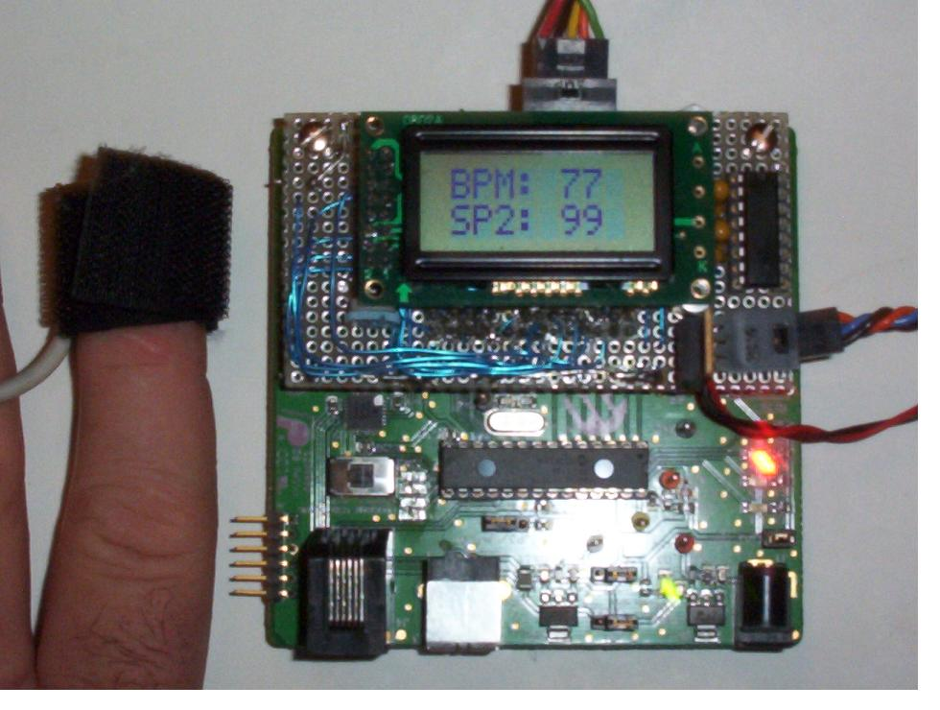

REFERENCES:

1. Hill Aileen , RRT : Recent Developments in Pulse Oximetry, RT – “The Journal for Respiratory Care Practitioners”, Oct/Nov 2000, p1
2. Kamat Vijaylakshmi : Pulse Oximetry, Indian Journal of Anesthesia, Aug 2002 p 261
3. Ekstrom Martin, Hagblad Jimmie: Pulse Oximetry – A computerized measurement and calculation system, Department of Computer Science and Electronics, Malardalens University, Mar –08-2005
4. Kastle, Noller, Falk,Butka,Mayer, Miller: A New Family of Sensors for Pulse Oximetry, Hewlett-Packard Journal, Feb 1997
5. Townsend, Neil: Medical Electronics, Michaelmas Term 2001